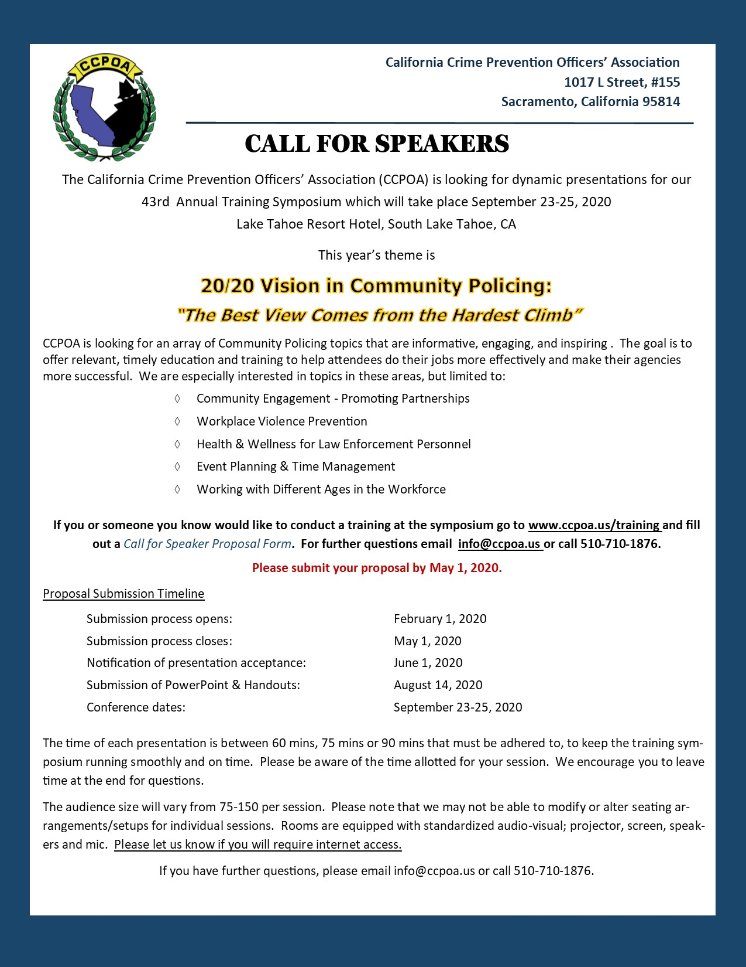
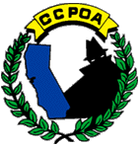
43RD ANNUAL CCPOA
TRaining SYMPOSIUM
SPEAKER proposal form

20/20 Vision in Community Policing:
“The Best View Comes from the Hardest Climb”
September 23-25-2020
South Lake Tahoe, California

The 43rd Annual California Crime Prevention Officers Association (CCPOA) Training Symposium will take place September 23-25, 2020 at the Lake Tahoe Resort Hotel, in South Lake Tahoe, CA. CCPOA is a non-profit professional organization that serves to facilitate training, networking and legislation for law enforcement, business and education professionals with a common goal of preventing crime. The symposium serves as a forum for our members to receive quality training, information and resources that they can take and implement at their respective agencies. Please submit your proposal by May 1, 2020.

Name: |  |  | Email:
Job Title: |  |  | Telephone:
Affiliation: |  |  | Subject  (please double click on the box and check one): |  | Basic Crime Prevention  Advanced Crime Prevention  Problem Solving  Program Implementation  Other (Please specify):
Address: |  |  | Level of Difficulty of the Course  (please double click on the box and check one): |  | Beginner  Intermediate  Advanced  General Audience
City:
State:
Postal Code:
Primary Trainer: |  |  | Secondary Trainer (If applicable):
Audio / Visual Needs (please list any specific audio/visual needs you have for your training). This includes laptop, projector, screen, microphone, audio, or internet access:

Presentation Title:
Biography of Primary Trainer  (please limit your bio to 1 paragraph, or  less than 200 words): |  |  |  | Biography of Secondary Trainer (if applicable - please limit your bio to 1 paragraph, or less than 200 words):
Training Abstract (The abstract should be a brief synopsis of your training.
You may attach a separate word document if necessary. Please limit your abstract to 500 words):
Symposium Schedule: September 23rd–24th 8AM-5PM, and 25th 8AM-12PM

Please mark below which day(s) and time of day works best for you and we will work with you to confirm an exact time slot.
Wednesday the 23rd morning Wednesday the 23rd afternoon

Thursday the 24th morning Thursday the 24th afternoon

Friday the 25th morning Circle One: Time slots are 60 mins, 75 mins or 90 mins

SUBMISSION INFORMATION:
Upon completion, please send your application to Gale Bleth via email: info@ccpoa.us or mail to: Hayward Police Department – Attention Gale Bleth: 300 W. Winton Avenue, Hayward, CA 94544. We strongly encourage you to send your submissions electronically.
Proposal forms due: May 1, 2020 at 5:00 PM.

ACCEPTANCE INFORMATION:
The presenter(s) will receive notification by June 1, 2020. If accepted, CCPOA will cover 1-night stay at the venue hotel. CCPOA does not pay presenters nor reimburse for travel or additional hotel expense.

For more information about the 43rd Annual CCPOA Training Symposium, please visit www.ccpoa.us.

